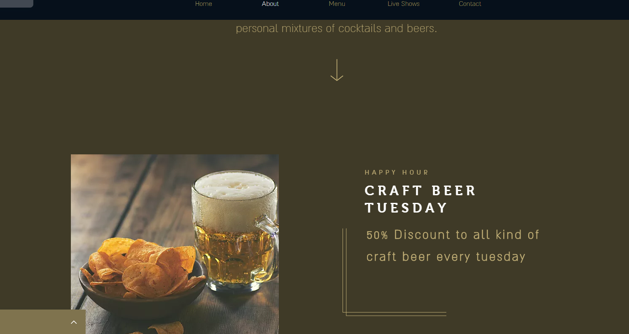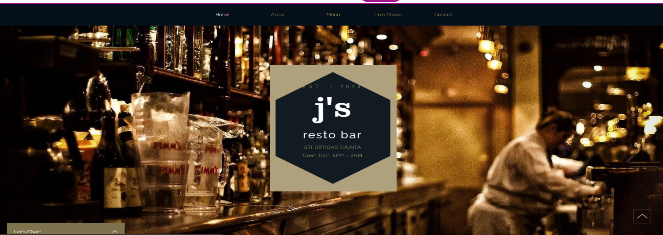

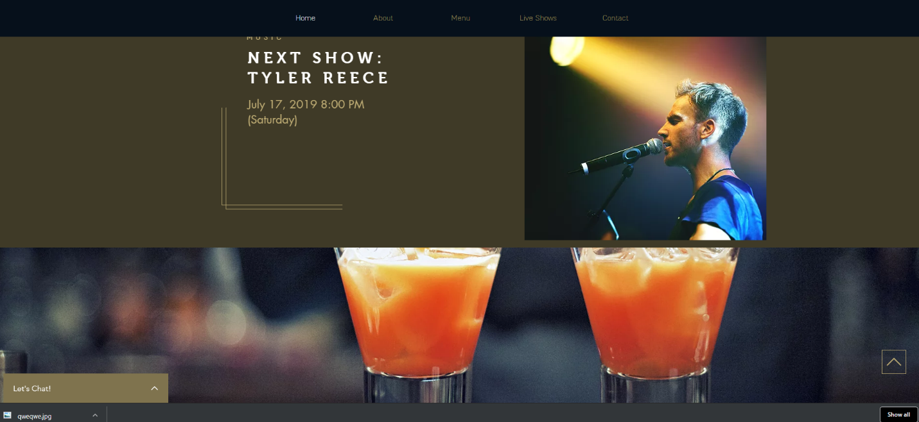

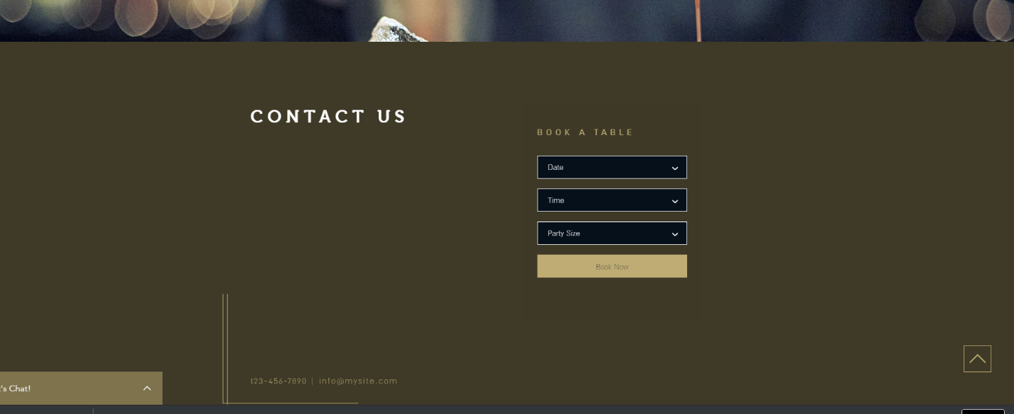

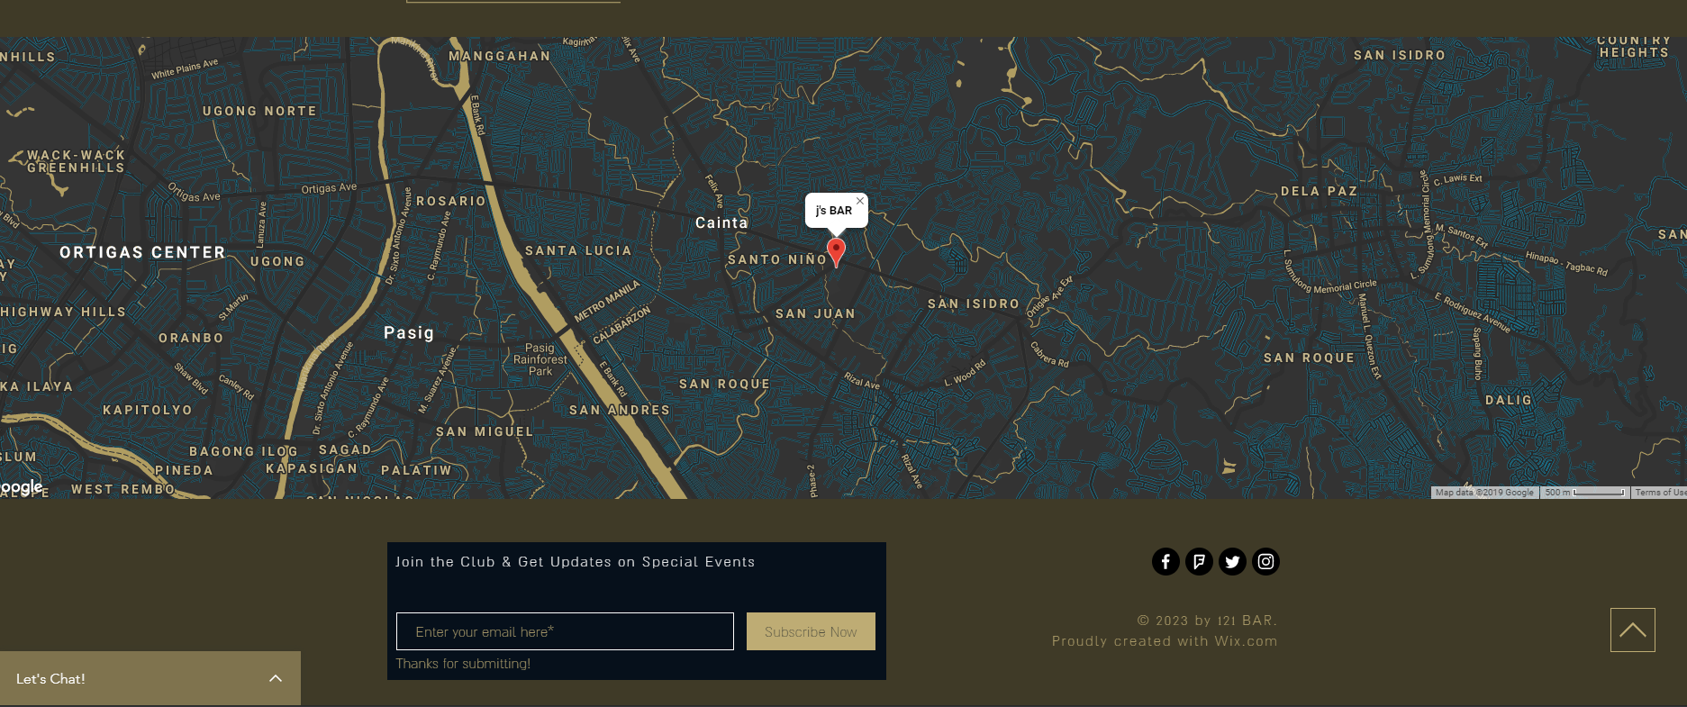

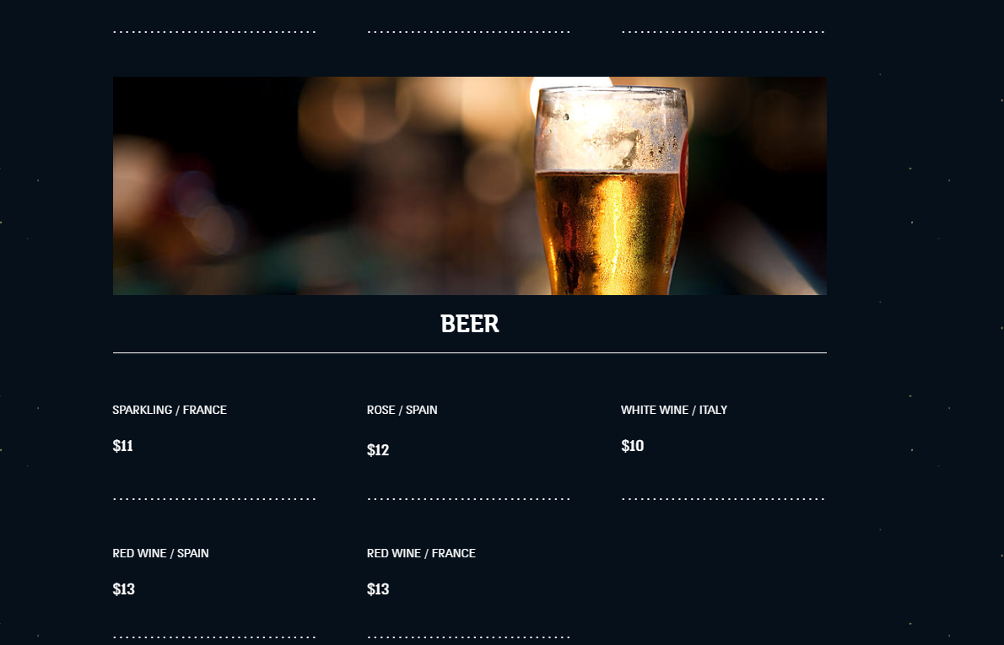

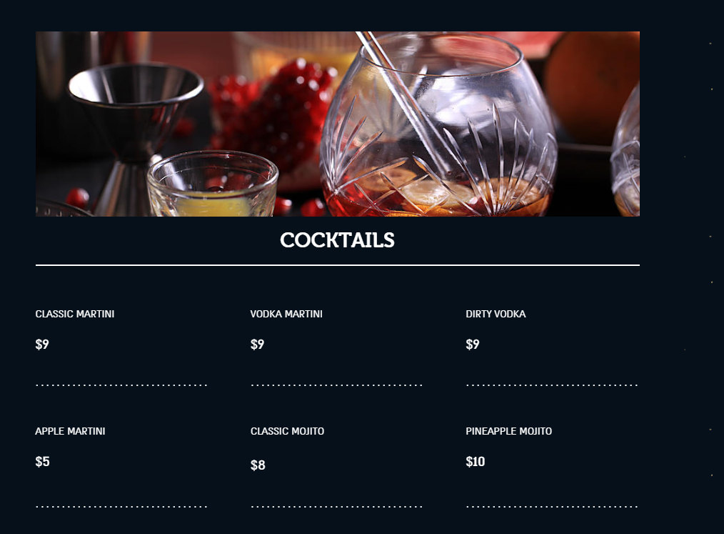

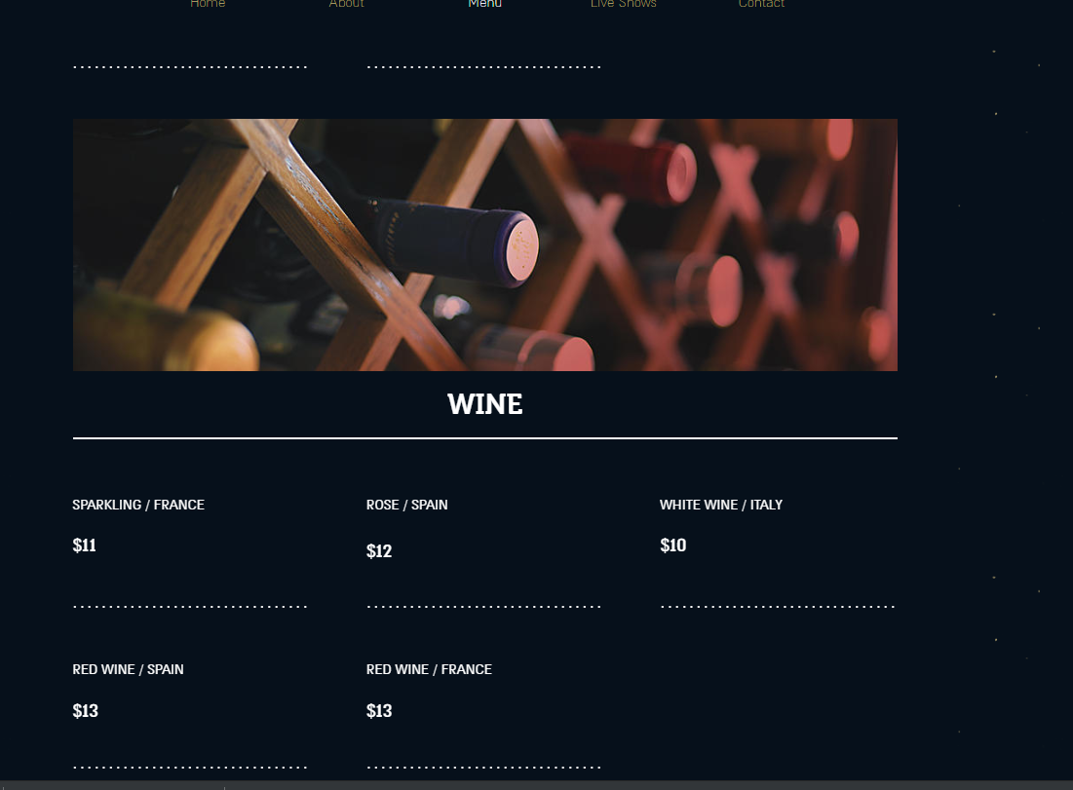

**Jaryd O. Mundas BSIT305  
J’S RESTO BAR**

The purpose of this website is to promote my store and to tell my customers that my store can serve them good drinks and food, if they visit the website they can book a table, check the prices, promos, location and events.

I made this website because I want to own a resto bar, because if I own a business like this I can go here when im tired from work to relax and also I can bring my friends here to enjoy but the most important I know that this will be a good source of income.